A 1. Standard definition

D 2. There's a pretty famous formula for this question that states the distance between the intersection of AC and DB and the line BC is AB\*DC/(AB+DC). This proof involving similar right triangles will be left as an exercise to the reader. Applying that formula twice, we obtain C.

C 3. The outside surface area is 9\*6 = 54. The surface inside is 6. 6 + 54 = 60

B 4. There are 18 configurations for a quarter twist, so our maximum bound is 18\*18 = 324. There are 18 cases where if one twists the cube back the original position using only quarter turns. Then there are the cases where the twists are coplanar and can have different order; a total of 3\*2\*3 = 18 exists. Last, there are the cases where we basically turn the face a whole 180, then there are two ways to get to that position; there are 18 ways to get to a 180 twists, so we need to subtract 9. 324-18-18-9 = 279.

D 5. Standard definition

C 6. The angles should add up to 180 since it's a straight line. 180 -34 = 146

E 7. There's a direct correlation between passing through a square and passing through one of the square’s sides (either a horizontal and vertical line). For a line (we can visualize the path as a line) to pass through a square it must hit a line. There's 7+7 = 14 lines. so there are 14+1 since we need to add one for the initial box.

A path is shown below:

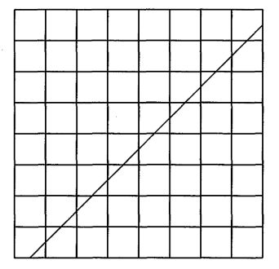

B 8. Since the ratio of the area is given, we just square root it to find the ratio of the sides.

A 9. The radius would be 3, and then square it and multiply by

B 10. Angle FAB will be 41 degrees and that means the arc subtended by angle FAB in the smaller circle will have 82 degrees too. Setting the center of the smaller circle as P, angle CPB will be 82 degrees. Since CB is tangent, there's a right triangle forcing CBA to be 8 degrees and thus AD to be 16.

A 11. The hexagon would tessellate as the measure of the angle is 120, which is divisible by 360.

C 12. We can just list out the possibilities as there are only 4 total.

E 13. The side of the cube is 3 inches = 1/4 feet. 1/4 cubed is not an answer choice.

D 14. The perpendicular bisector will create a right angle, meaning HALF the line segment will be 12 units long.

D 15 Contaminant A and B can be on the same line.

D 16. If the contaminants are spaced in an equilateral triangle with the bot in the middle, the area will be maximized resulting in answer D

B 17. Only contrapositive is true

A 18. Simple application, just follow the direction in the description of Menelaus's theorem.

C 19. From the information given, we know there's a right angle at B, meaning if we find the length of the hypotenuse, we can find the area. Applying the theorem to triangle CBE with line FXA, we obtain CX as 1; AC well be . The area divided by  will be 8.

B 20. Applying Menelaus's theorem on triangle ACL with line KPB, and using the fact that C has an angle bisector, we find out that 2CP = 5PL. Then (as the hints said) the parallelogram of MAPC gives us the length of CP as 180, thus PL = 72. (Note: this is a very hard problem, is you got this right, give yourself a cookie)

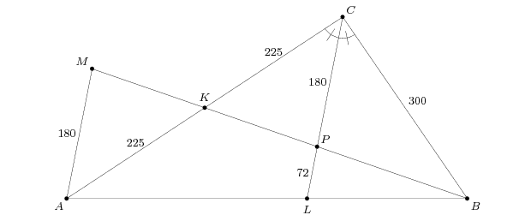

A 21. We first find the area of the equilateral triangle inside first:  . Next we find the area of the rectangles: 5\*1\*3 = 15. Next the curved sectors (which is just a circle if you put them together: .

D 22. If you think in 3D, you can have a slice in a completely different plane from the first two and obtain 8 as the answer.

E 23. Using the property of intersecting chords, 5\*3 = 3\*x; x = 5. 5+3 = 8

C 24. There are 15 total diagonals in the hexagon. Unless you want to be super rigorous and add it all up, it should be common sense that 15 diagonals, though shorter, are longer than just 2 longer ones.

A 25. Commonly used for the sum of a triangle proof.

D 26. 5 = k/7, k = 35. h = 35/35, h = 1

B 27. The area outside the radius of 4 is . The area of the small circle summed together will be 

A 28. Adding the volume up for the HEMISPHERE and the cone results in this formula: 

C 29. Obvious

D 30. Draw a line through the 105 degree bend parallel to the two parallel lines. This allows us break down the 105 degrees into 75 and 30 degrees.